Module 9 - Kubernetes

Lab 1: Minikube Installation & Cluster Setup
- How do you install Minikube on your local machine?
- How do you start the Minikube cluster?
- How do you enable and access the Minikube dashboard?
- How do you verify the node status using kubectl?
- How do you verify the cluster status?

How do you install Minikube on your local machine?

If we stuck anywhere, we can check below URL to check it:
DevOps-Notes/Kubernetes/Kubernetes part 1.txt at master · Akshiv20/DevOps-Notes

1/ Docker installation:
sudo apt update
sudo apt-get install ca-certificates curl gnupg lsb-release
sudo mkdir -p /etc/apt/keyrings
curl -fsSL https://download.docker.com/linux/ubuntu/gpg | sudo gpg --dearmor -o /etc/apt/keyrings/docker.gpg
echo "deb [arch=$(dpkg --print-architecture) signed-by=/etc/apt/keyrings/docker.gpg] https://download.docker.com/linux/ubuntu \
$(lsb_release -cs) stable" | sudo tee /etc/apt/sources.list.d/docker.list > /dev/null
sudo apt-get update
sudo apt-get install docker-ce docker-ce-cli containerd.io docker-compose-plugin
sudo systemctl status docker
docker version

2. Need to check Kubectl is installed or not, if not installed, use below commands to use and install it.
Kubectl installation:

curl -LO "https://dl.k8s.io/release/$(curl -L -s https://dl.k8s.io/release/stable.txt)/bin/linux/amd64/kubectl"
chmod +x kubectl
sudo mv kubectl /usr/local/bin/

incase above command not worked :
sudo snap install kubectl –classic

To check the kubectl version:
kubectl version –client

kubectl get pods

3. Minikube insatllation

I am using below command which I get it from net and just run it.
Command:

curl -LO https://github.com/kubernetes/minikube/releases/latest/download/minikube-linux-amd64
sudo install minikube-linux-amd64 /usr/local/bin/minikube && rm minikube-linux-amd64
Then we use below command to check the status of installed minikube:

minikube start --driver=docker
minikube start --driver=docker --force
minkube status
minikube version

To check below commands:
kubectl cluster-info
kubectl config view
kubectl get nodes
kubectl get pods

11. Nginx deployment

kubectl create deployment nginx-web --image=nginx
kubectl expose deployment nginx-web --type NodePort --port=80
kubectl get deployment,pod,svc

12. Managing Minikube Addons

minikube addons list
minikube addons enable dashboard
minikube addons enable ingress
minikube addons list (to confirm all the addons)
minikube dashboard

13. Managing Minikube Cluster

minikube stop
minikube start

14. Delete Cluster
minikube delete

Minikube dashboard is enabled when I tried in ubuntu, the same which I tried in EC2 server through putty not enabled.

Local check:
Screenshots:
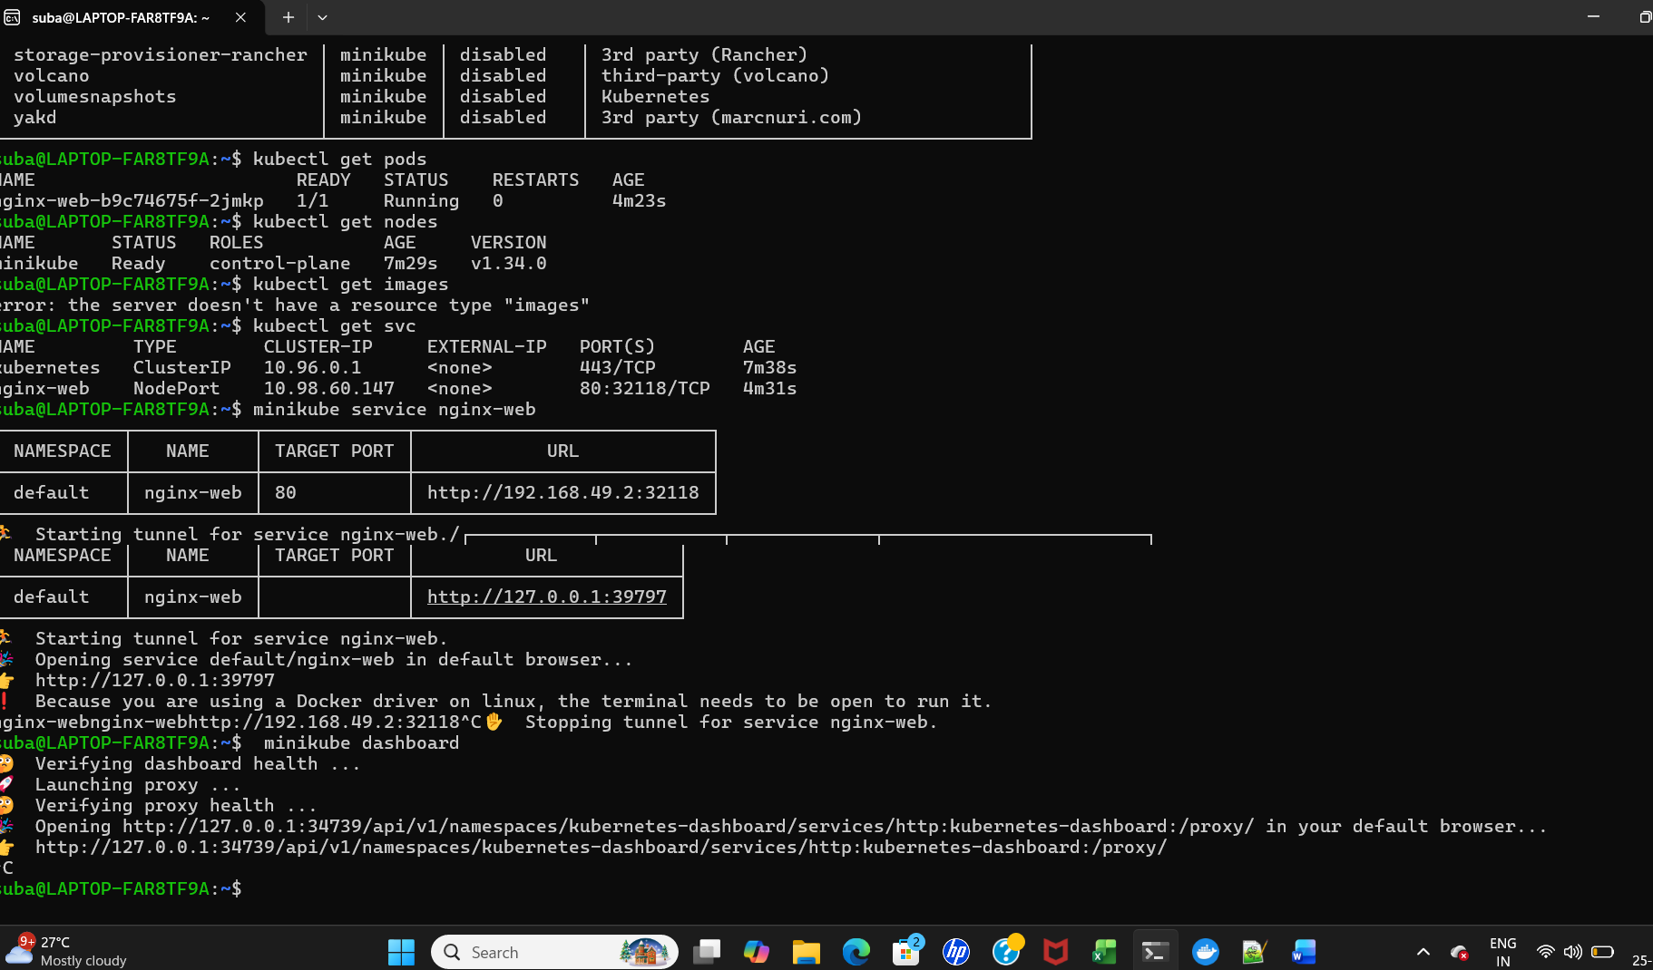

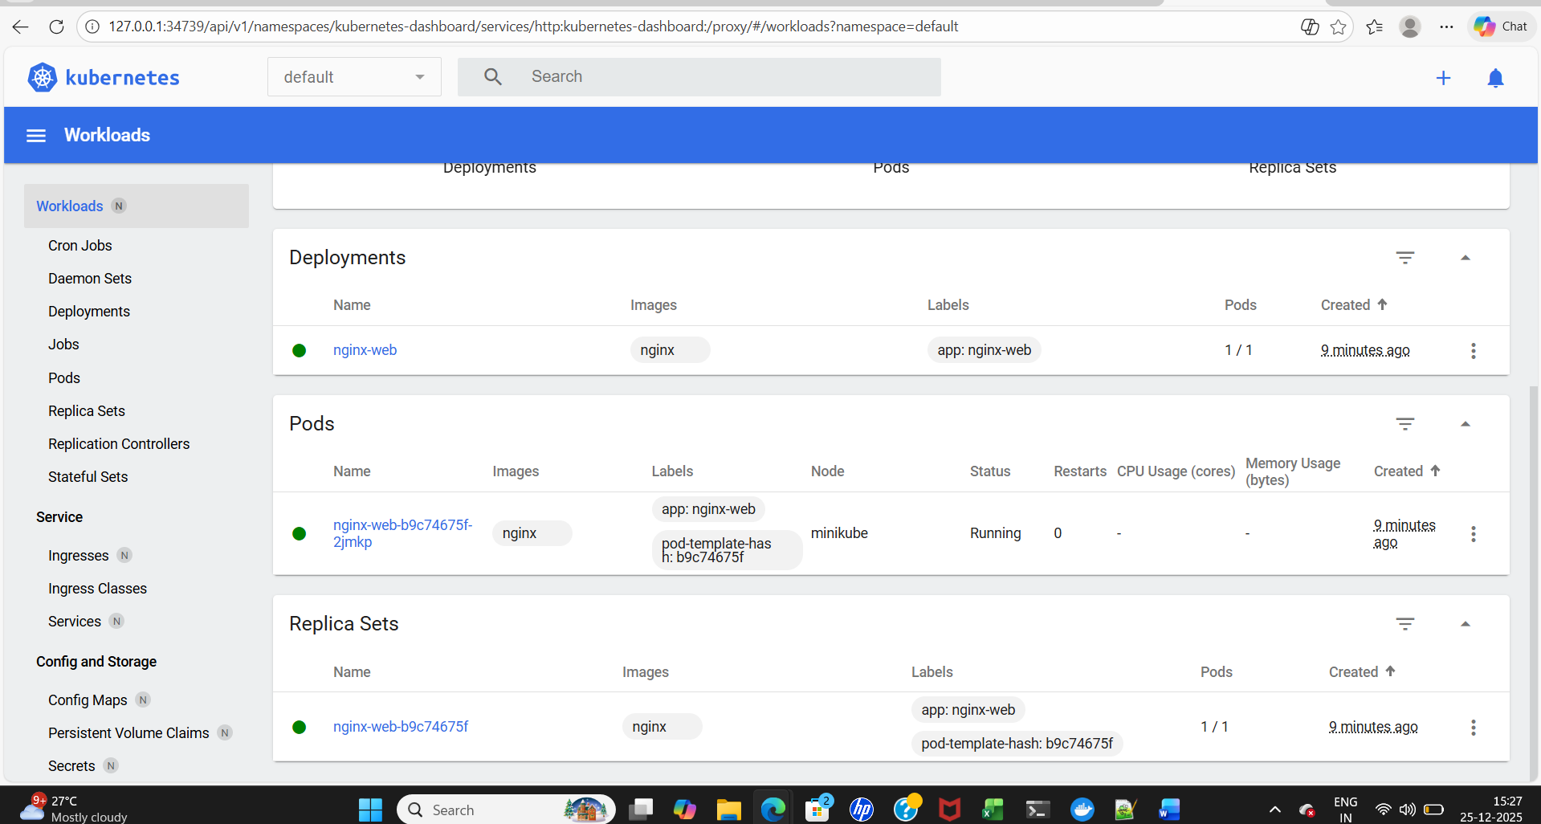
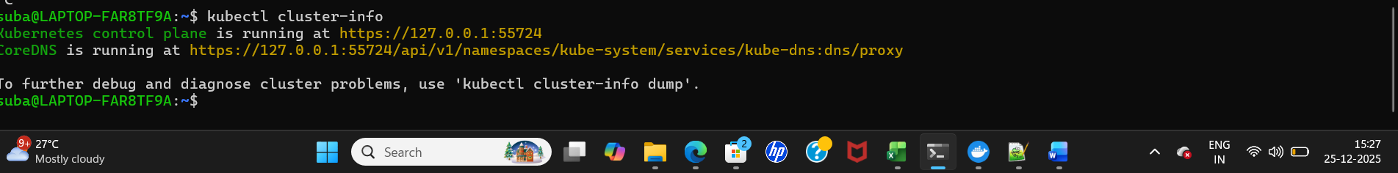
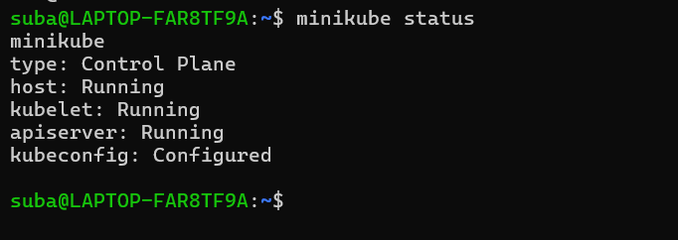

Lab 2: Create an EKS Cluster Using eksctl
- How do you create an EKS cluster using eksctl with two worker nodes?
- How do you configure kubectl to access the newly created EKS cluster?
- How do you verify cluster connectivity and node health?
DevOps-Notes/Kubernetes/Demo of Creating an EKS cluster using eksctl.txt at master · Akshiv20/DevOps-Notes
create an EKS cluster using eksctl:
1. EC2 machine created.
2. IAM -role - ec2 full access --(AdministratorAccess) --> created and attach it in EC2 machine.
3.run the below commands
4. sudo apt install unzip
4. then run the below commands
curl "https://awscli.amazonaws.com/awscli-exe-linux-x86_64.zip" -o "awscliv2.zip"
unzip awscliv2.zip
sudo ./aws/install
5. check aws cli is created or not
aws s3 ls
6. then follow the belw steps:
7/curl --silent --location "https://github.com/eksctl-io/eksctl/releases/latest/download/eksctl_$(uname -s)_amd64.tar.gz" -o eksctl.tar.gz
9/tar -xzf eksctl.tar.gz
10. Move eksctl to the directory in your PATH: sudo mv eksctl /usr/local/bin

11. Verify installation: eksctl version

12. Make sure kubectl is installed: kubectl version --client

8. To install kubectl, i use below commands

curl -LO "https://dl.k8s.io/release/$(curl -L -s https://dl.k8s.io/release/stable.txt)/bin/linux/amd64/kubectl"
chmod +x kubectl
sudo mv kubectl /usr/local/bin/

9/ follow the steps:

https://github.com/Akshiv20/DevOps-Notes/blob/master/Kubernetes/Demo%20of%20Creating%20an%20EKS%20cluster%20using%20eksctl.txt

create EKSctl

eksctl create cluster \
--name demo-cluster \
--region ap-south-1 \
--nodegroup-name demo-nodes \
--node-type t3.medium \
--nodes 2

Screenshot:
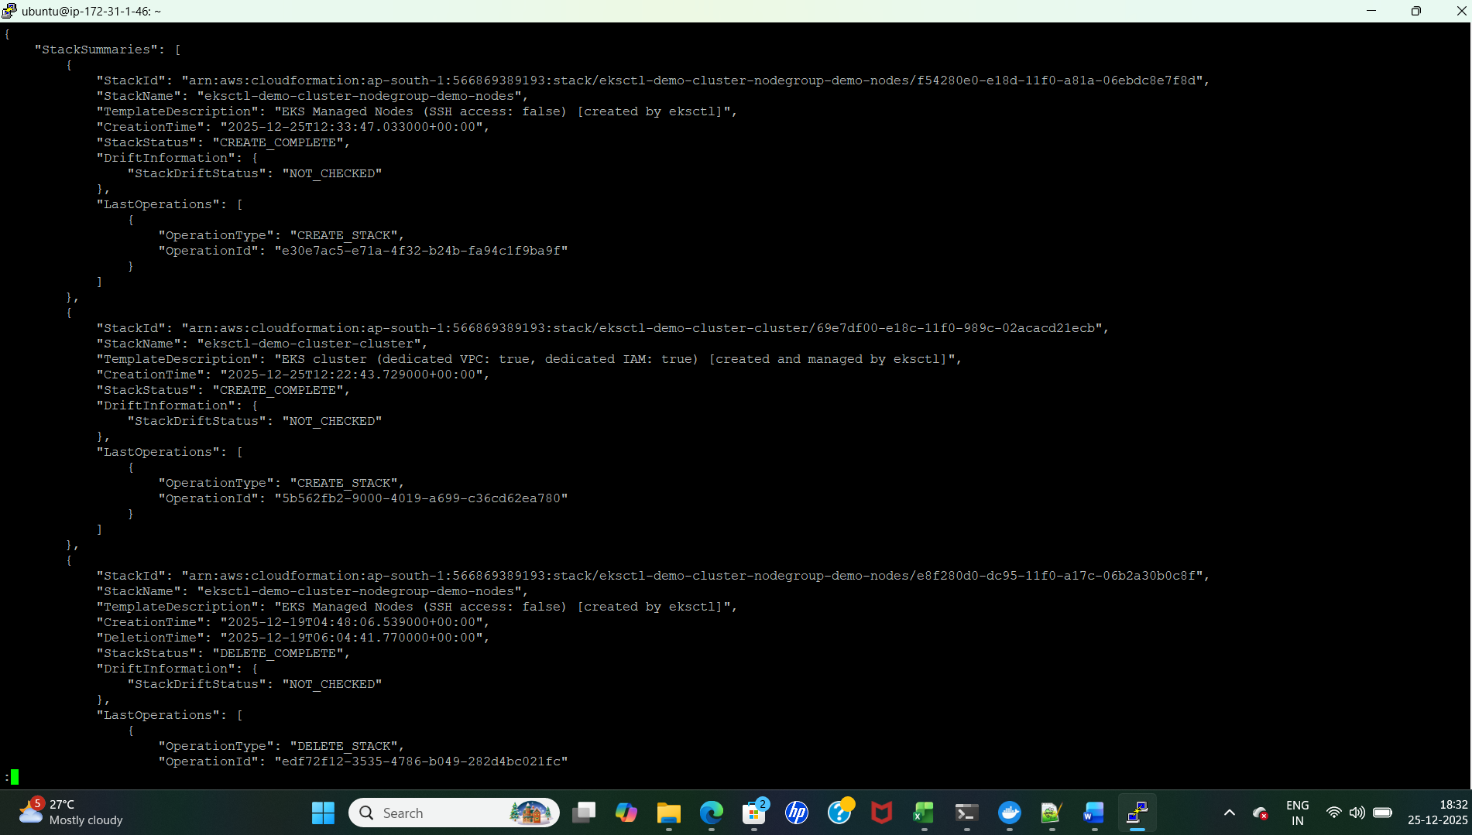
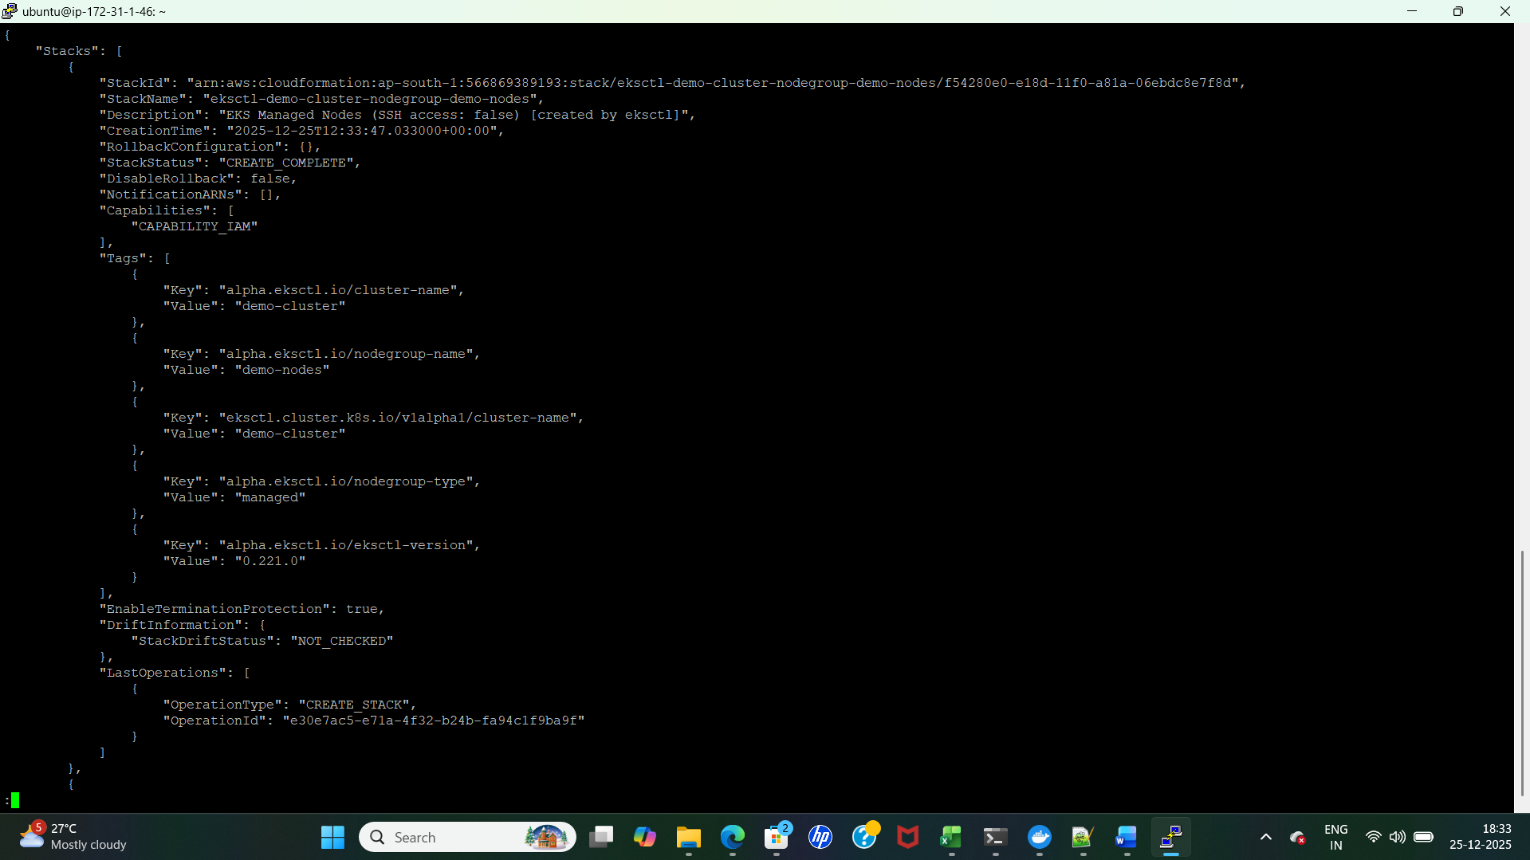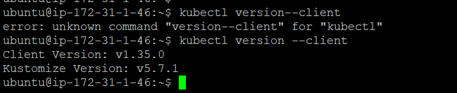
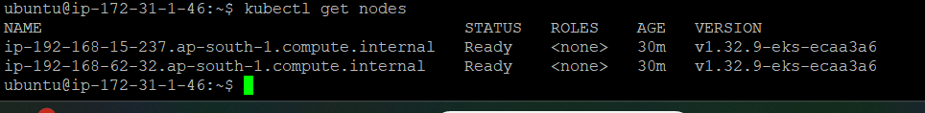
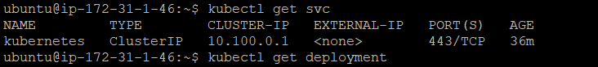
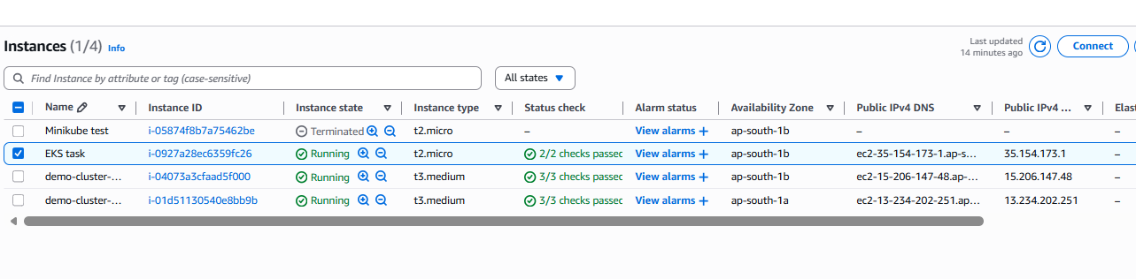
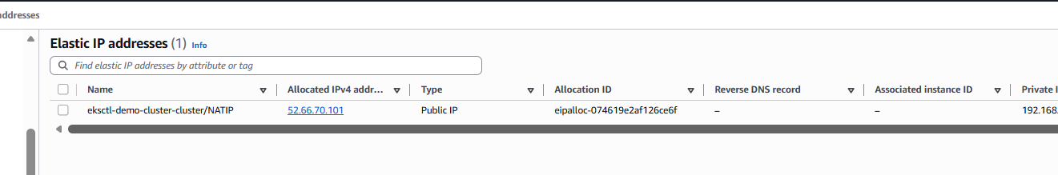

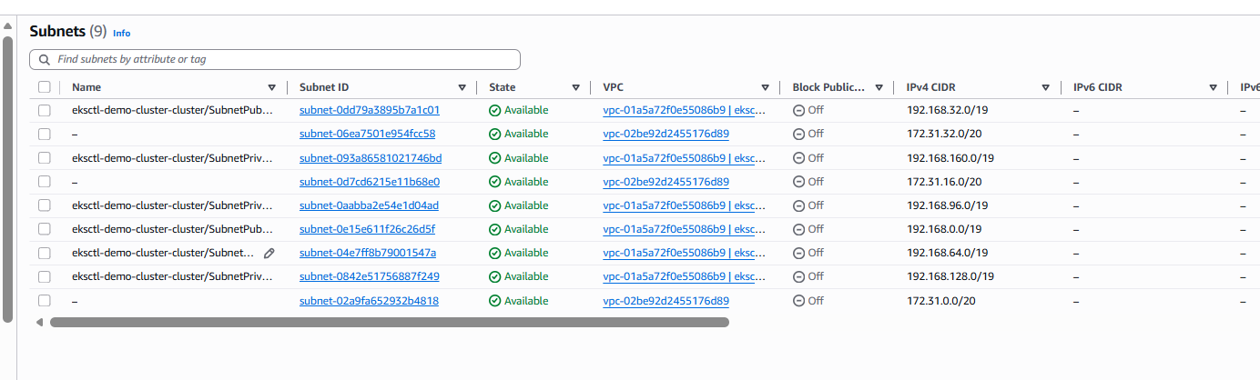

Lab 3: Deploy and Scale Nginx
- How do you deploy a sample Nginx application using a Deployment YAML?
- How do you scale replicas from 1 to 5?
- How do you verify the deployment rollout status? Meant ? check deployment status ?
- How do you check rollout history and revisions?

minikube kubectl -- get pods -A
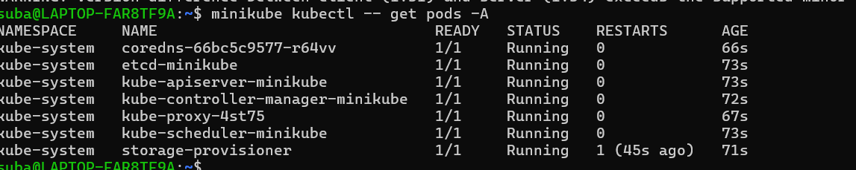

8. Deployment:
The most common Kubernetes object.
Use a Deployment when you need:
. Auto restarts
. Rolling updates
. Rollbacks
. Multiple replicas
This is how 99% of web apps/API backends are deployed.

Useful kubectl commands:
------------------------
kubectl get deploy # list deployments
kubectl describe deploy <name> # events & rollout info
kubectl apply -f deployment.yaml # create/update deployment
kubectl delete deploy <name>
kubectl rollout status deploy/<name> # check rollout progress
kubectl rollout history deploy/<name> # see revisions
kubectl rollout undo deploy/<name> # rollback to previous
kubectl scale deploy/<name> --replicas=5
kubectl set image deploy/<name> <container>=<image>:<tag> # update image
kubectl get rs # list replicasets created by deployments
kubectl get pods -l app=web # list pods of deployment by label

kubectl rollout undo deployment/<deployment-name> --to-revision=2
kubectl apply -f depoymentfile name --record (it will show the history of your deployment

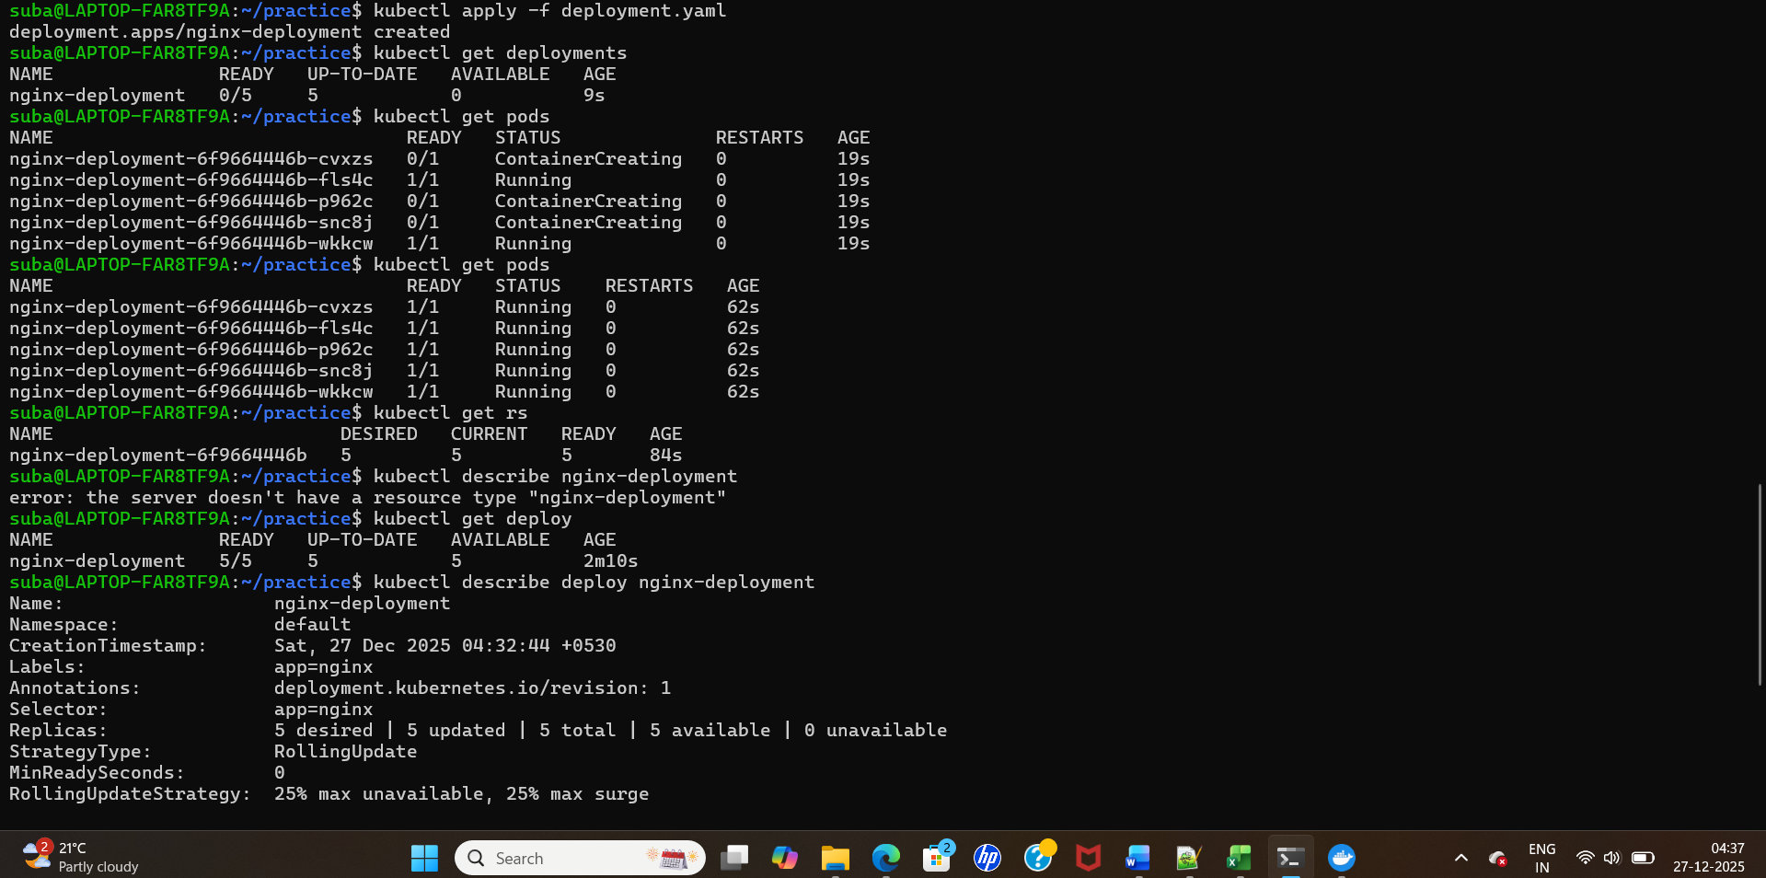
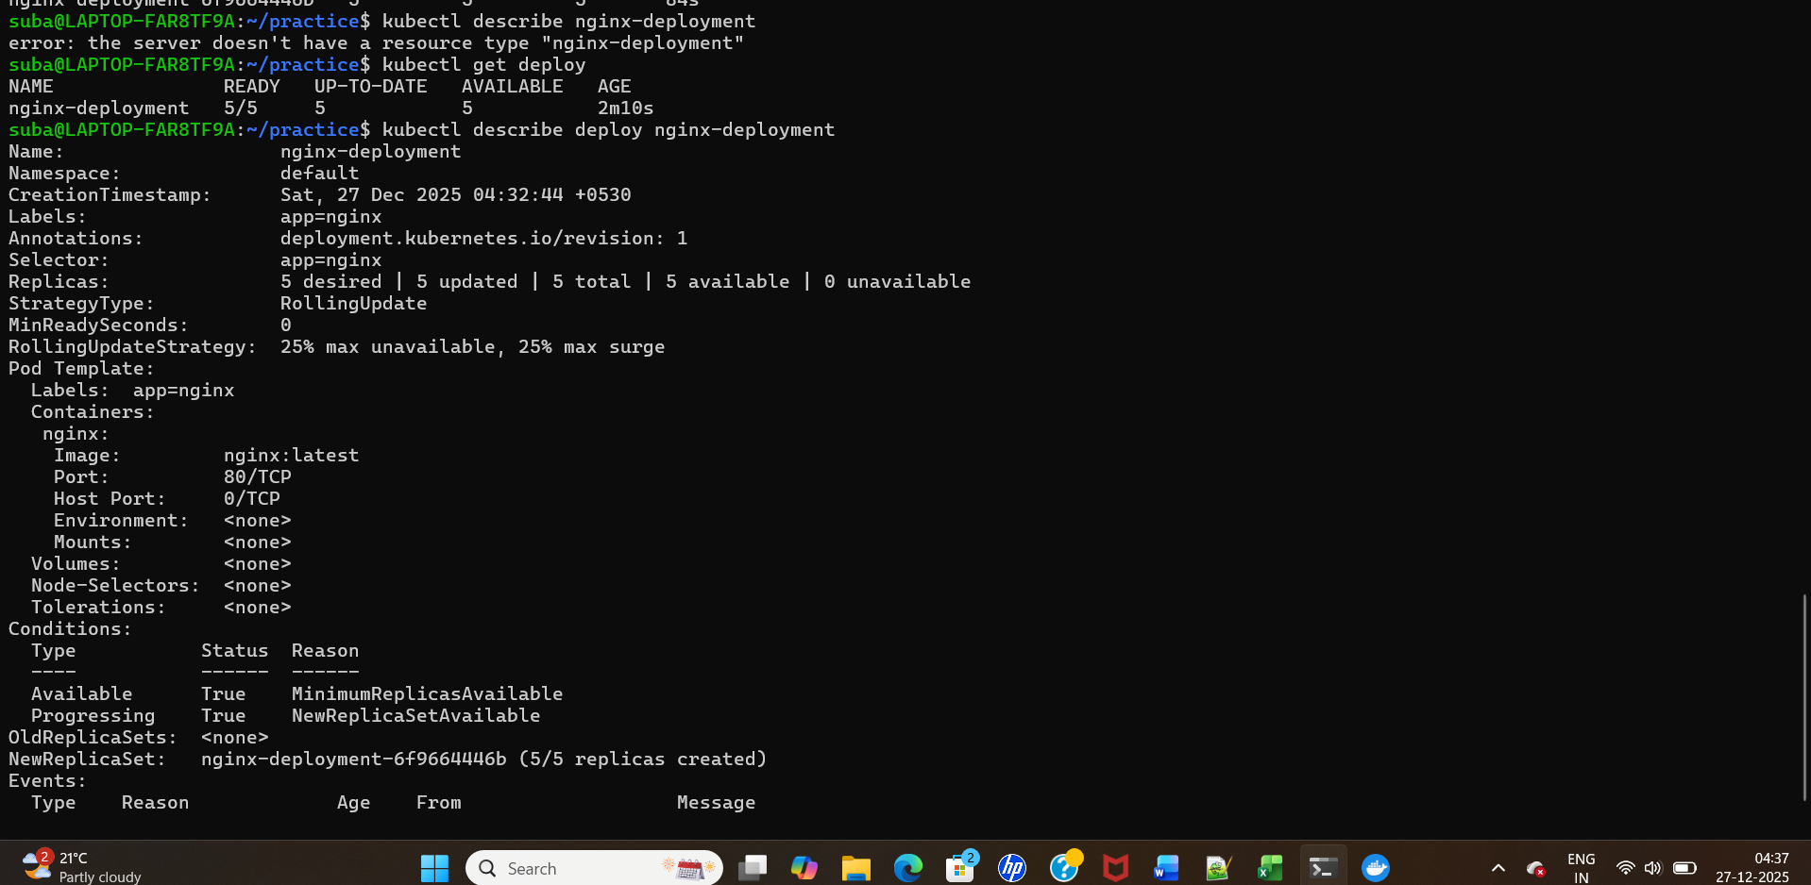
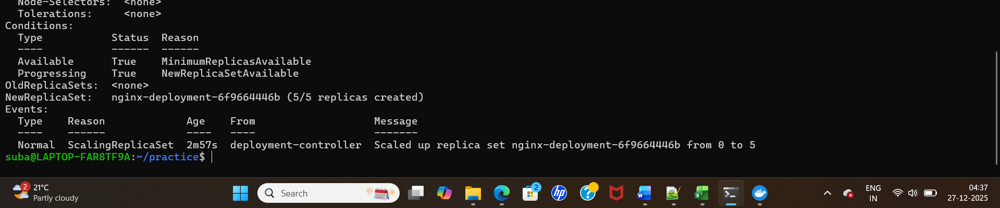
Replica is working:
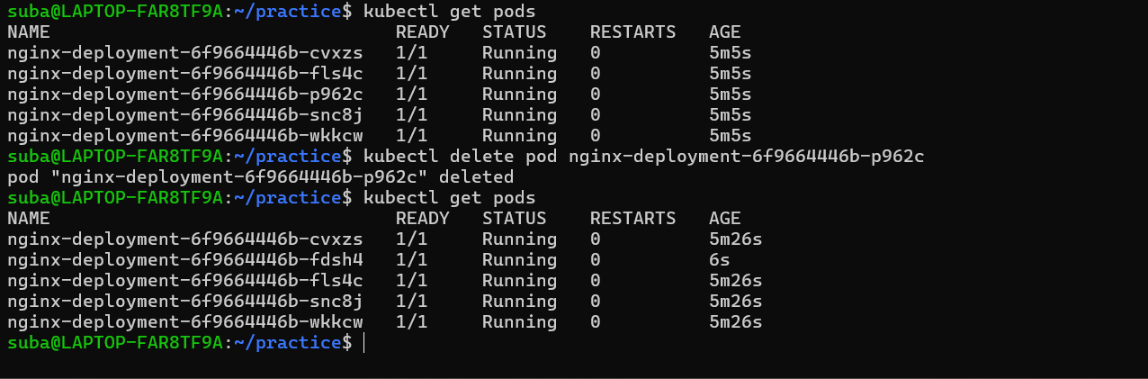
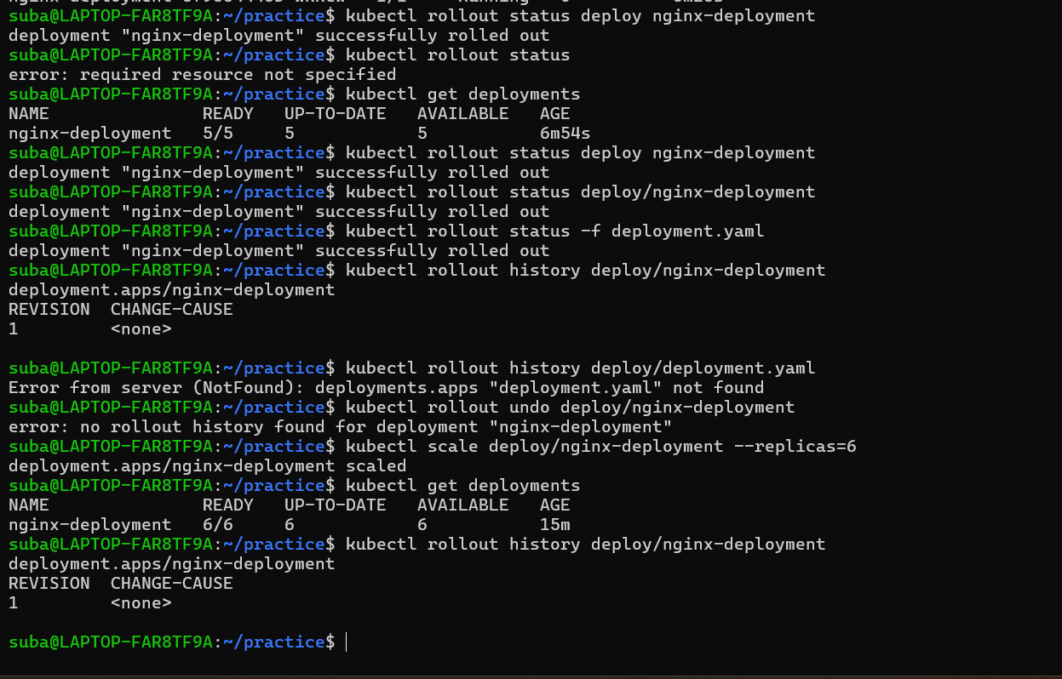

Lab 4: Create and Test Kubernetes Services
- How do you create a ClusterIP service for the Nginx deployment?
- How do you create a NodePort service?
- How do you create a LoadBalancer service?
- How do you test application access for each service type?

Kubectl get ingress
Kubectl describe ingress ingressname
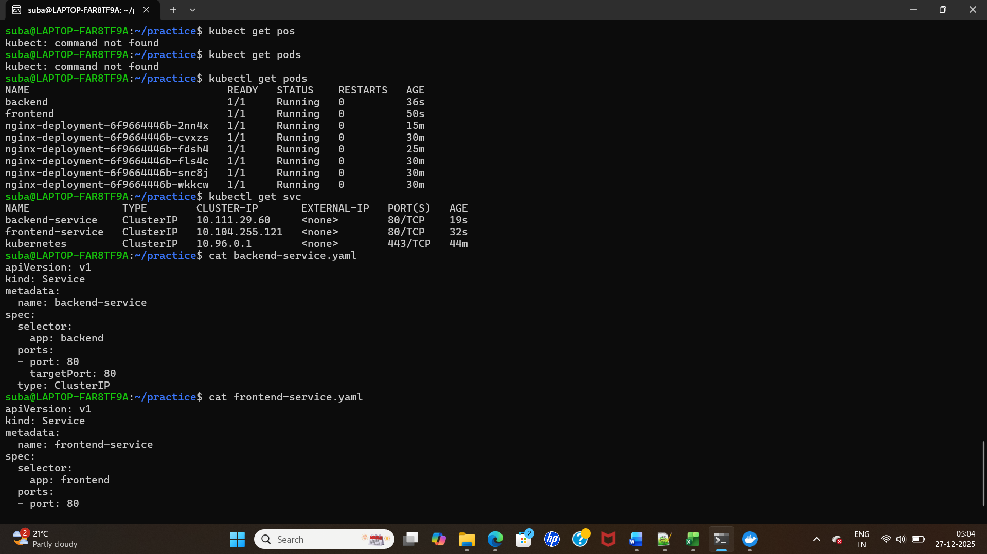
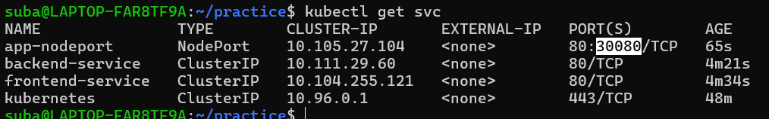

Lab 5: Work With Kubernetes Namespaces
- How do you create a new namespace? Kubectl create ns suba , kubec tl get ns
- How do you deploy resources inside the new namespace? Need to mention the namespace in yaml file, and use below command to verify whether our resource is created under this name space or not
kubectl get pods -n suba
- How do you switch between namespaces using kubectl config set-context?
kubectl config set-context --current --namespace = suba (It will set default ns)
kubectl config set-context sri --namespace = suba1
kubectl config use-context <context-name>
- How do you verify that resources are isolated in the namespace?

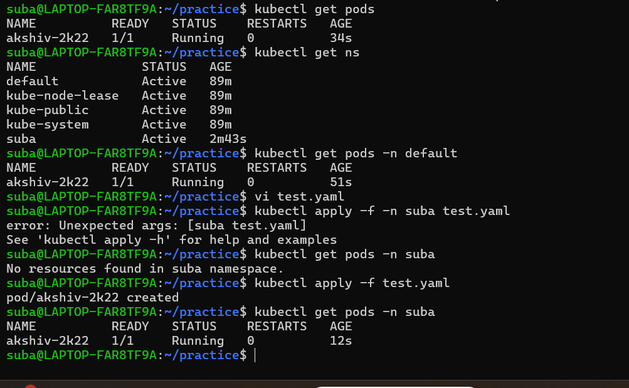

Lab 7: ConfigMaps & Secrets
- How do you create a ConfigMap?
- How do you create a Secret?
- How do you mount both into a Pod as environment variables? Doubt
- How do you mount them as volume mounts? How do verify the volume mount
- How do you verify that the Pod reads the values properly?

kubectl get configmap
kubectl describe configmap <name>
kubectl create configmap app-config --from-literal=APP_MODE=production --from-literal=API_URL=http://backend-svc
kubectl create configmap app-config --from-file=./config/ # from files
kubectl apply -f configmap.yaml
kubectl delete configmap app-config
kubectl get configmap -o yaml

YAML example:
-------------

apiVersion: v1
kind: ConfigMap
metadata:
name: app-config
data:
APP_MODE: "production"
API_URL: http://backend-svc

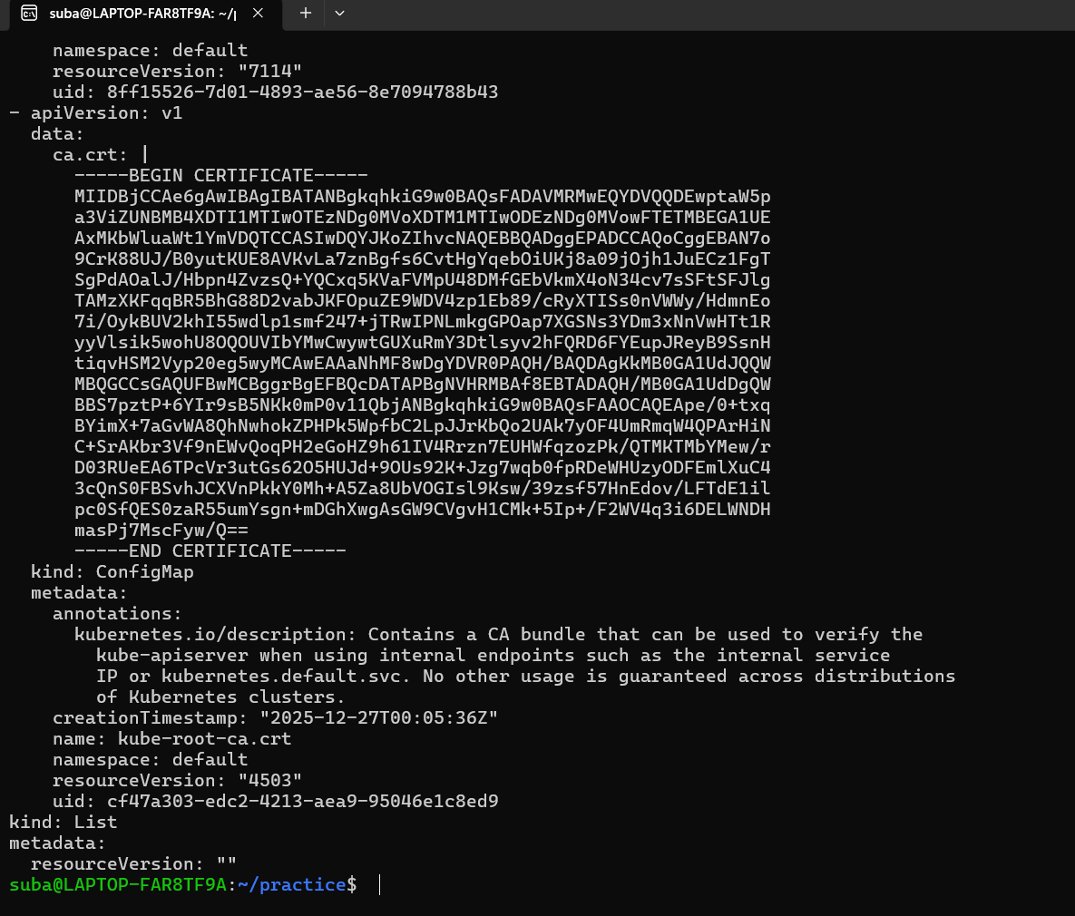

6. Secret:
Stores sensitive data (passwords/keys). Values are base64-encoded in data and treated with stricter RBAC.
Stores sensitive configuration such as:
. DB passwords
. API tokens
. TLS certificates
Pods can mount these values as env variables or files.

Useful kubectl commands:
------------------------
kubectl get secret
kubectl describe secret <name> # shows keys, NOT values
kubectl get secret <name> -o yaml # full object (values base64)
kubectl create secret generic db-secret --from-literal=username=admin --from-literal=password=secret
kubectl create secret generic db-secret --from-file=./cert.pem
kubectl create secret tls tls-secret --cert=cert.pem --key=key.pem
kubectl apply -f secret.yaml
kubectl delete secret db-secret
# to see decoded value (locally):
kubectl get secret db-secret -o jsonpath="{.data.username}" | base64 –decode

- How do you mount both into a Pod as environment variables? Need yp check

apiVersion: v1
kind: Pod
metadata:
name: envar-demo
labels:
purpose: demonstrate-envars
spec:
containers:
- name: envar-demo-container
image: gcr.io/google-samples/hello-app:2.0
env:
- name: DEMO_GREETING
value: "Hello from the environment"
- name: DEMO_FAREWELL
value: "Such a sweet sorrow"

How do we verify the volume mount :
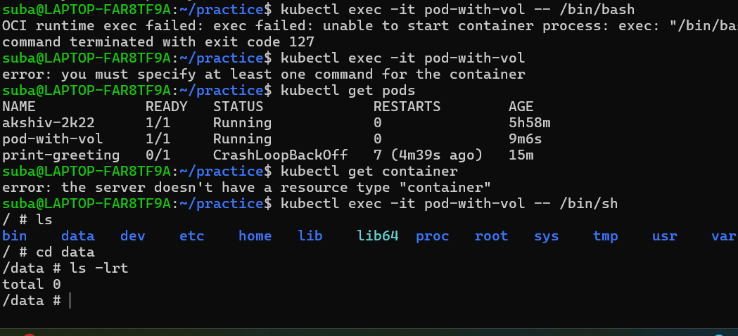

Lab 8: StatefulSet & Persistent Volume Claims
- How do you create a StatefulSet using Persistent Volume Claims?
- How do you deploy a database such as MySQL or MongoDB using the StatefulSet?
- How do you verify that data persists after a pod restarts?
- How do you inspect the PV and PVC status? Kubectl get pv and kubectl get pvc
Kubectl describe pv pvname

How do you verify that data persists after a pod restarts?
- Create PV
- Create PVC
- Create POD
- Delete the pod and check the file is present or not after creating a new pod.
Error : unable to creaete a pod getting PV not found .

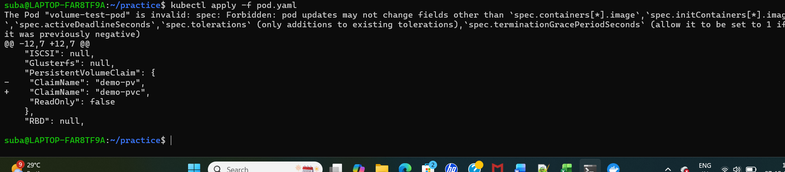

Lab 9: Helm Installation & Chart Deployment
- How do you install Helm on your local machine? Helm install
- How do you add a Helm repository? helm repo add bitnami https://charts.bitnami.com/bitnami
- How do you deploy a Helm chart (Nginx, Prometheus, or WordPress)?
helm repo update
helm install my-nginx bitnami/nginx
helm list
helm uninstall my-nginx

- How do you override default Helm values with a custom values file?
- How do you verify the release status?
helm status <release-name>
helm list -A
Check status of specific names pace
helm status my-nginx -n web

Lab 6: Implement Horizontal Pod Autoscaling
- How do you configure an HPA for an existing deployment?
- How do you generate CPU load to trigger scaling?
- How do you verify that pods scale up and scale down?

Lab 10: RBAC Configuration
- How do you create a Kubernetes service account?
- How do you create a Role that grants view-only access to a namespace?
- How do you bind the Role to the service account using a RoleBinding?
- How do you validate that the service account can only view resources and cannot modify them?

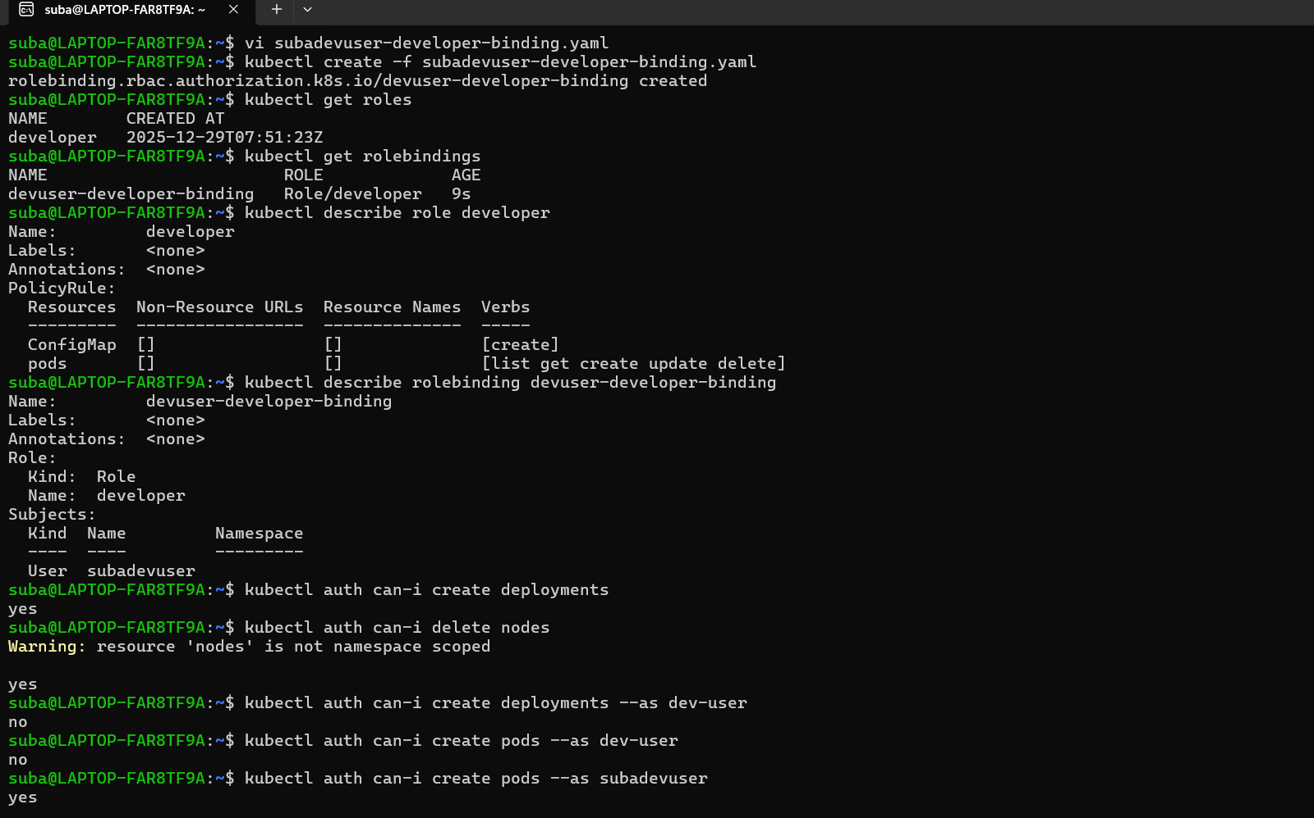

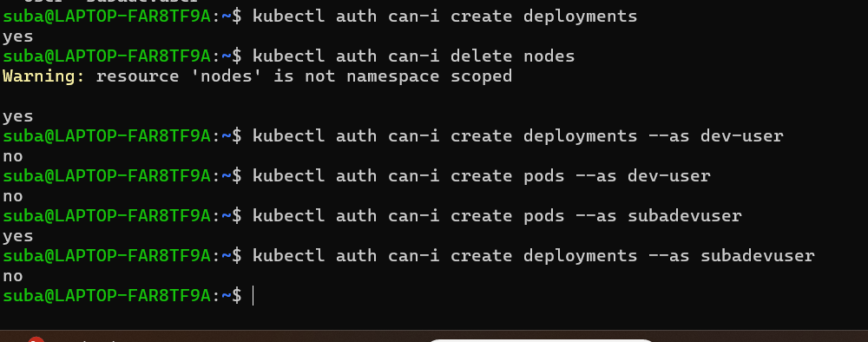

Files:
apiVersion: rbac.authorization.k8s.io/v1
kind: Role
metadata:
name: developer
rules:
- apiGroups: [""]
resources: ["pods"]
verbs: ["list", "get", "create", "update", "delete"]
- apiGroups: [""]
resources: ["ConfigMap"]
verbs: ["create"]

kubectl create -f developer-role.yaml

apiVersion: rbac.authorization.k8s.io/v1
kind: RoleBinding
metadata:
name: devuser-developer-binding
subjects:
- kind: User
name: subadevuser
apiGroup: rbac.authorization.k8s.io
roleRef:
kind: Role
name: developer
apiGroup: rbac.authorization.k8s.io

kubectl create -f subadevuser-developer-binding.yaml

kubectl get roles
kubectl get rolebindings
kubectl describe role developer
kubectl describe rolebinding devuser-developer-binding

check authorization:
kubectl auth can-i create deployments
# Output: yes
kubectl auth can-i delete nodes
# Output: no
kubectl auth can-i create deployments --as subadevuser
# Output: no
kubectl auth can-i create pods --as subadevuser

--------------------------------------------------------------------------------------------------------------------------------------------------

apiVersion: rbac.authorization.k8s.io/v1
kind: Role
metadata:
namespace: dev
name: developer
rules:
- apiGroups: [""]
resources: ["pods"]
verbs: ["list", "get", "create", "update", "delete"]
- apiGroups: [""]
resources: ["ConfigMap"]
verbs: ["create"]

kubectl create -f dev-role.yaml -n dev

apiVersion: rbac.authorization.k8s.io/v1
kind: RoleBinding
metadata:
namespace: dev
name: devuser-developer-binding
subjects:
- kind: User
name: devuser
apiGroup: rbac.authorization.k8s.io
roleRef:
kind: Role
name: developer
apiGroup: rbac.authorization.k8s.io

kubectl create -f devuser-developer-binding.yaml -n dev

kubectl get roles
kubectl get rolebindings
kubectl describe role developer
kubectl describe rolebinding devuser-developer-binding

check authorization:
kubectl auth can-i create deployments
# Output: yes
kubectl auth can-i delete nodes
# Output: no
kubectl auth can-i create deployments --as subadevuser
# Output: no
kubectl auth can-i create pods --as subadevuser

